**PIZZA SALES SQL QUERIES**

1. **KPI’s**

**1.Total Revenue:**

select sum(total_price) as total_revenue from pizza_restraunt_sale;

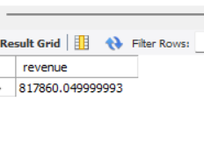

**2.Average order value:**

select (sum(total_price))/count(distinct(order_id)) as average_order_value from pizza_restraunt_sale;

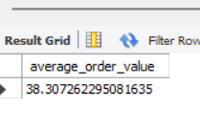

**3.Total Pizzas Sold:**

select sum(quantity) as Total_pizzas_sold from pizza_restraunt_sale;

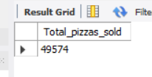

**4.Total order:**

select count(distinct(order_id)) as Total_orders from pizza_restraunt_sale;

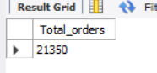

**5.Average pizza per order**

select round((sum(quantity))/(count(distinct order_id)) ,2) as avg_pizzas_order from pizza_restraunt_sale;

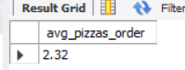

1. **Daily Trend for Total Order**

select day (order_date) as order_day,count(distinct order_id) as total_orders from pizza_restraunt_sale group by day(order_date);

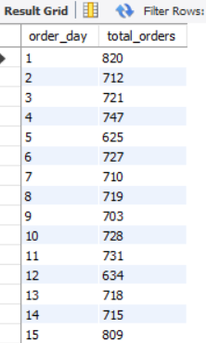

1. **Hourly Trend for Orders**

select hour(order_time) as order_hours, count (distinct order_id) as Total_orders from pizza_restraunt_sale group by hour(order_time) order by order_hours;

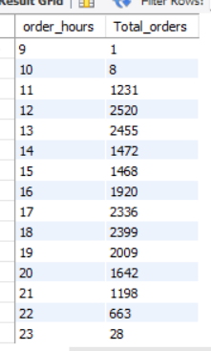

**D.% of Sales by pizza Category:**

select pizza_category, round(sum(total_price),2) as Total_Revenue, round((sum(total_price))*100/(select sum(total_price) from pizza_restraunt_sale),2) as percentage from pizza_restraunt_sale group by pizza_category;

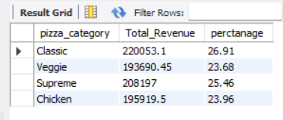

**E.% of sales by Pizza Size:**

select pizza_size, round(sum(total_price),2) as Total_Revenue,

round((sum(total_price)) *100/ (select sum(total_price) from pizza_restraunt_sale),2) as percentage

from pizza_restraunt_sale

group by pizza_size

order by pizza_size;

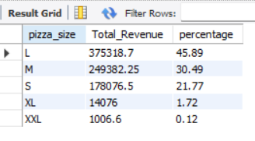

**F. Total Orders by Pizza Category:**

select pizza_category, sum(quantity)as total_qty_sold

from pizza_restraunt_sale

where month(order_date) = 2

group by pizza_category

order by Total_qty_sold desc;

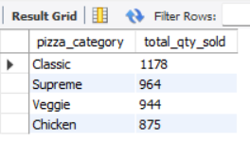

**G. Top 5 Best seller by Total Pizzas sold:**

select pizza_name, sum(quantity) as TOTAL_PIZZA_SOLD from pizza_restraunt_sale

group by Pizza_name order by SUM (quantity) desc limit 5;

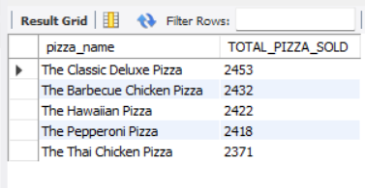

**H. Bottom 5 Worst Seller by Total Pizzas Sold:**

select pizza_name, sum(quantity) as TOTAL_PIZZA_SOLD from pizza_restraunt_sale

group by Pizza_name order by SUM (quantity) limit 5;

